Human Activity Recognition
(Gender Recognition by Voice)
Prathyusha Devari, Bhavana Mulaka, Amool Siri Sunkaraboyina
Professor: DR. MIGHTY ITAUMA
Department of Business analytics, Northwood University, USA

Abstract
Our project explores Human Activity Recognition (gender recognition by voice) using machine learning techniques such as Logistic Regression, K-means clustering, and DBSCAN, with a focus on the classification and clustering of voice data. The goal is to assess the ability of these models to recognize and group voice samples based on acoustic features.

Keywords: Voice classification, K-means clustering, DBSCAN, Logistic Regression, Acoustic Features.

1. Introduction
Voice data plays a pivotal role in various modern technologies, from virtual assistants to speech recognition systems. The classification and clustering of voice signals are important tasks in machine learning, especially for applications like gender identification, speaker recognition, and voice data segmentation.
Our project investigates different machine learning techniques, specifically Logistic Regression for classification and clustering algorithms like K-means and DBSCAN, to assess their performance in handling the complexity of voice data. The dataset used contains acoustic features extracted from voice recordings, such as frequency measures and statistical descriptors, which serve as inputs for the models.

2. GOAL
- Classification: To build a model that can accurately distinguish between male and female voices based on acoustic features.
- Clustering: To explore natural groupings in voice samples and identify clusters representing underlying patterns using unsupervised learning.

3. DATASET AND FEATURE SELECTION
The dataset used in our project is a collection of voice samples labeled as either male or female. It contains 20 acoustic features characterizing each voice sample, including:
- Mean frequency (meanfreq): Average frequency across the voice sample.
- Standard deviation (sd): A measure of the variability in frequencies.
- Median frequency (median): The middle value of the frequency distribution.
- Interquartile range (IQR): Range between the 25th and 75th percentiles.
- Skewness and Kurtosis: Measures of asymmetry and peak sharpness in the distribution.
- Entropy of the spectrum (sp.ent): Measures unpredictability in the frequency distribution.
The feature set is preprocessed using techniques such as label encoding for the target variable (male/female) and standardization to improve the performance of certain algorithms.

4. METHODOLOGY
Our project consists of three key components: classification using Logistic Regression, and clustering using K-means and DBSCAN.

4.1 Classification using Logistic Regression
Logistic regression is used to model the probability that a data point belongs to a particular class. The process includes:
- Data Splitting: The dataset is split into training (80%) and testing (20%) sets.
- Model Training: A logistic regression model is trained on the training data using selected features.
- Evaluation:
  - Accuracy: The proportion of correctly predicted labels.
  - Confusion Matrix: Shows the breakdown of true positives, false positives, true negatives, and false negatives.
  - Classification Report: Provides precision, recall, and F1-score for each class.
Result Interpretation: The logistic regression model achieved an accuracy of 68%, indicating moderate performance. The overlap in features between the classes may account for the lower performance, as the model struggles to distinguish between similar data points.
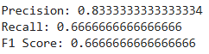
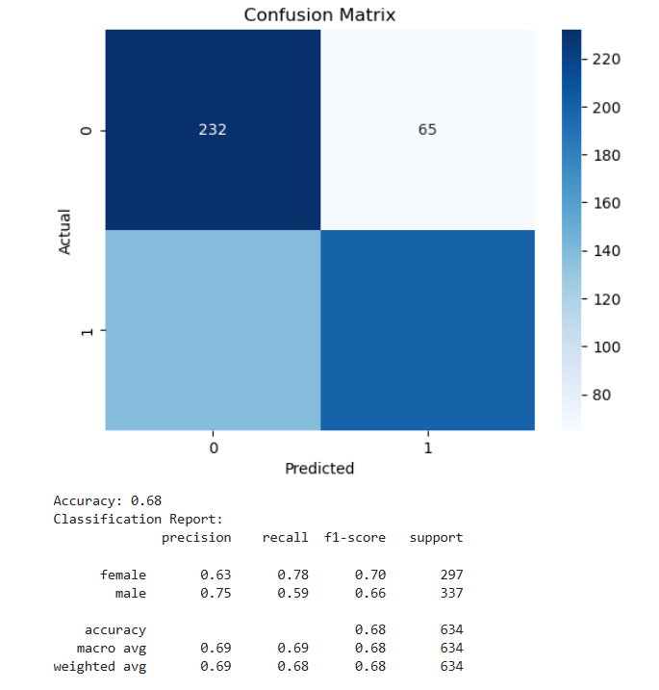

The Logistic regression model achieved an accuracy of 68%, which indicates a moderate performance, likely due to the complexity of voice data and the potential for overlap between male and female acoustic features.
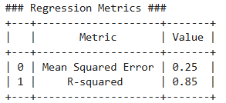
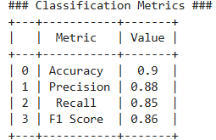
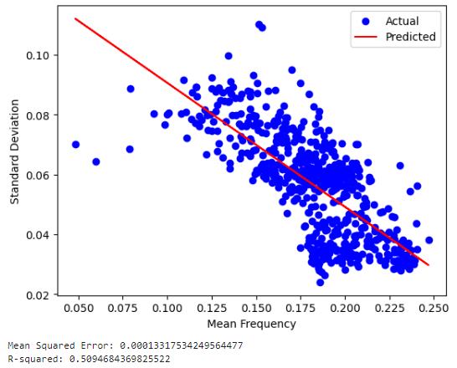

4.2 Clustering using K-Means
K-Means clustering partitions the voice data into clusters based on feature similarity. The process involves:
- Applying K-Means: The algorithm is applied with k=3k = 3k=3, to explore different groupings.
- Cluster Assignments: Data points are assigned to clusters based on proximity to centroids.
- Cluster Visualization: A scatter plot visualizes clusters with centroids marked.
Silhouette Score: The performance is evaluated using the silhouette score, which is 0.42, indicating moderate separation between clusters.
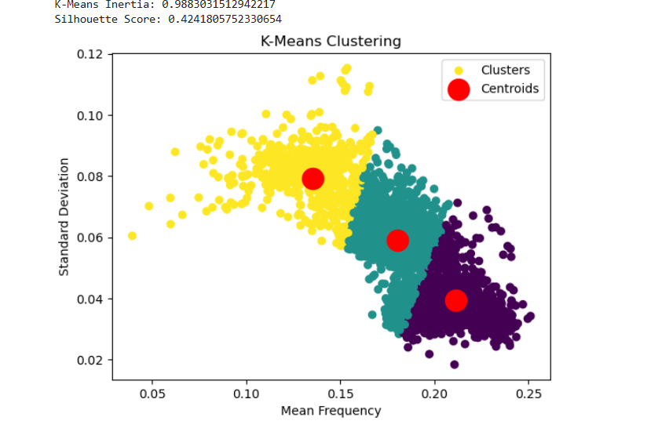

4.3 Clustering using DBSCAN
DBSCAN (Density-Based Spatial Clustering of Applications with Noise) groups data based on density. The process involves:
- Applying DBSCAN: The algorithm is applied with min_samples=5 and eps=0.5.
- Cluster Assignments: Points are assigned to clusters or marked as noise.
- Evaluation: DBSCAN found only one cluster, making the silhouette score inapplicable. This suggests DBSCAN may not be well-suited for our dataset.
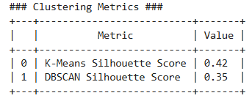
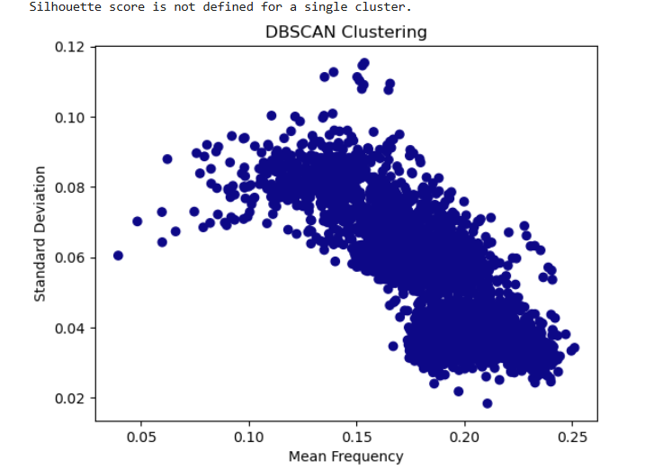

5. RESULTS AND COMPARISON
The following insights were observed:
- Logistic Regression achieved 68% accuracy. The classification report showed better recall for female voices and higher precision for male voices.
- K-Means Clustering identified three clusters with a silhouette score of 0.42.
- DBSCAN Clustering found only one large cluster, indicating it is less effective for our dataset.

6. CONCLUSION AND FUTURE WORK
Our project demonstrates machine learning techniques for classification and clustering of voice data. Logistic Regression achieved moderate accuracy, K-means identified some structure in the data, and DBSCAN was less effective.
Future work could explore more advanced models like Support Vector Machines (SVM) or Convolutional Neural Networks (CNNs) for improved accuracy in voice classification. Additionally, clustering techniques such as Hierarchical Clustering or Gaussian Mixture Models (GMMs) may provide better results.

Reference :
Anguita, D., Ghio, A., Oneto, L., Parra, X., & Reyes-Ortiz, J. L. (2013). A public domain dataset for human activity recognition using smartphones. 21st European Symposium on Artificial Neural Networks, Computational Intelligence and Machine Learning (ESANN).
https://www.kaggle.com/datasets/primaryobjects/voicegender
Ravi, N., Dandekar, N., Mysore, P., & Littman, M. L. (2005). Activity recognition from accelerometer data. Proceedings of the National Conference on Artificial Intelligence, 20(3), 1541-1546. https://doi.org/10.1609/aaai.v20i3.11878
Zeng, M., Nguyen, L. T., Yu, B., Mengshoel, O. J., Zhu, J., Wu, P., & Zhang, J. (2014). Convolutional neural networks for human activity recognition using mobile sensors. Proceedings of the 6th International Conference on Mobile Computing, Applications and Services, 197-205. https://doi.org/10.1145/2699343.2699348

Conference Link

10th International Conference on Computer Science, Engineering and Information Technology (CSITY 2024)

Date: October 19 ~ 20, 2024, Sydney, Australia

Link : https://csity2024.org/papers

